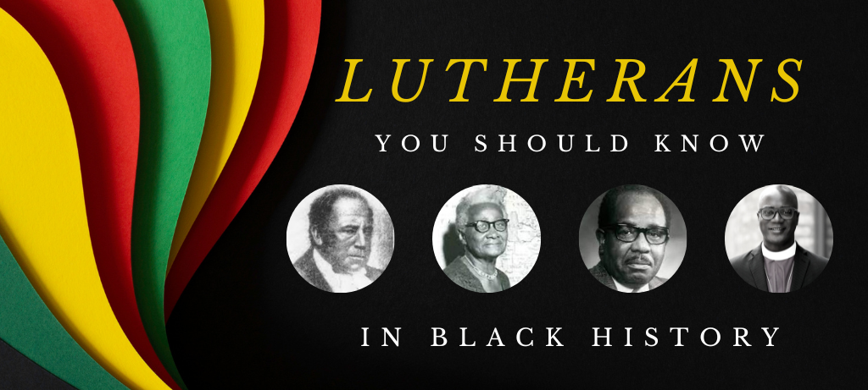

To honor Black History Month in the ELCA Florida-Bahamas Synod, the Just Love Team presents “Lutherans You Should Know in Black History.” We present four outstanding African Americans who made a difference in the Lutheran Church. Their stories are not widely known, but they made significant impacts to the church. We will hear how they persevered during the following four eras in U.S. History:

- Pre-Civil War Era (Pastor Jehu Jones)
- Jim Crow Era (Dr. Rosa Young)
- Civil Rights Era (Rev. Dr. Nelson Trout)
- Contemporary (Bishop Yehiel Curry)

We ask each congregation to present the Lutherans You Should Know in Black History summary each week in February. It can be done during announcements, a bulletin insert, or wherever fits best into the service. Each week we offer songs and prayers for use during the service.

For pastors and liturgical leaders, there are several resources in Sundays and Seasons that can be emphasized during Black History Month: We suggest congregations to use This Far By Faith hymnal in February. This Far by Faith is available on SundaysAndSeasons.com.

- Week 1: Jehu Jones (First Black ordained Lutheran minister)
- Week 2: Rosa Young (Educator and known as the Mother of Black Lutheranism)
- Week 3: Nelson Trout (First Black Lutheran bishop)
- Week 4: Bishop Yehiel Curry (Current Chicago Metropolitan Synod Bishop and our companion synod)

Scripture – Philemon 1: 15-19
Perhaps the reason he was separated from you for a little while was that you might have him back for good. No longer as a slave, but better than a slave, as a dear brother. He is very dear to me but dearer to you both as a man and is a brother in the Lord. So, if you consider me a partner, welcome him as you would welcome me. If he has done you any wrong or owes you anything, charge it to me. I, Paul am writing this with my own hand. I will pay it back—not to mention than you owe me your very self.

Summary
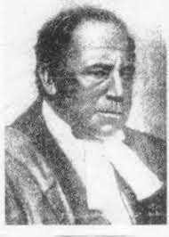
Jehu Jones Jr., the first African American Ordained Lutheran Pastor, was born in Charleston, South Carolina on September 4, 1786 to slave parents, Jehu Sr. and Abigail Jones. Jones’ parents were freed in 1798.

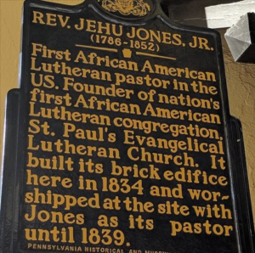
Jones was originally affiliated with the Episcopal Church but, finding himself increasingly drawn to Lutheranism, around 1820 he became a member of St. John’s Lutheran Church in Charleston. With the encouragement of his pastor, the Reverend John Bachman, Jones traveled to New York to be ordained by the New York Synod in 1832 as a missionary to Liberia to help freed slaves transition to that country. However, when Jones returned to Charleston after being ordained, he was briefly jailed for violating a law prohibiting freed blacks from returning to a state they had left.

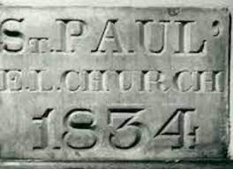
After his release Jones moved to Philadelphia, Pennsylvania, and in June 1833 the Pennsylvania ministry decided that he should be appointed “to labor as a Missionary… among the colored people in Philadelphia under the direction of our Ministers.” On February 16, 1834, the St. Paul’s congregation that Jones founded decided to build a church with the help of other Lutheran congregations. Four months later Jones purchased two lots on 150 S. Quince Street for the church to be built. Assisted by Pastors Philip Mayer of Philadelphia and Benjamin Keller of St. Michael’s Church in Germantown, Jones laid the cornerstone for the building.

The first congregation of St. Paul’s Lutheran Church was composed of twenty impoverished black Philadelphians.

Song Recommendations
- Lift Every Voice and Sing – Hymn #295 (Appropriate Anytime)

Pre-Civil War Era (Slavery)
- Wade in The Water – Hymn#114
- Swing Low – Sweet Chariot – Hymn#171
- Go Down Moses – Hymn#87
- Nobody Knows the Trouble I’ve Seen

Petition for prayers of the people

Weekly Prayer (for individuals, small groups or the prayer of the day. Write yourself or use this one)
Heavenly Father,
Gratitude should be our constant companion. Release my limiting beliefs and I will claim the power of God, a strength beyond mere human strength. I will live with assurance and positive expectancy of my faith. I am open and receptive to the divine flow of life, love, and possibilities. I say yes to prosperity, healing, harmony, and peace. I say yes to my good and love today and every day. I (We) ask this in your Son’s holy name.
Amen

Offering Prayer
Liberating God, you break the bonds of injustice and let the oppressed go free. Receive these offerings in thanksgiving for all your works of merciful power, and freedom. You we magnify and adore, through Jesus our Savior.
Amen

Blessing
The God who faithfully brings forth justice and breaks the oppressor’s rod + bless, strengthen, and uphold you today and always.
Amen

Jehu Jones Additional Information:
- Article: Fate, M. (2014, April 16). Jehu Jones Jr. (1786-1852). BlackPast.org. https://www.blackpast.org/african-american-history/jones-jehu-jr-1786-1852/

- Article: Johnson, Jr., Karl E. and Joseph A Romeo. “Jehu Jones (1786-1852): The First African American Lutheran Minister.” Lutheran Quarterly X, no. 4 (Winter 1996)
- Video: Jehu Jones and African American Lutherans https://www.google.com/url?sa=t&rct=j&q=&esrc=s&source=web&cd=&ved=2ahUKEwj37LWnscj8AhUWEFkFHQayBq0Q78AJegQIDBAB&url=https://www.youtube.com/watch?v=JvJPTZSFWxI&usg=AOvVaw3qjv-t9_hkFu_m2dwe-lcU
- Video: Remembering Pastor Jehu Jones https://www.google.com/url?sa=t&rct=j&q=&esrc=s&source=web&cd=&cad=rja&uact=8&ved=2ahUKEwjKnY2Xp8j8AhWxMlkFHVpYDEAQFnoECAkQAQ&url=https://ne-np.facebook.com/zionlutheranperry/videos/849325956262401/&usg=AOvVaw3m_XfLIeiUQLb4zGPMT4GA

Scripture - Deuteronomy 30:9b; 20
Choose life so that you and your descendants may live, 20loving the Lord your God, obeying him, and holding fast to him; for that means life to you and length of days, so that you may live in the land that the Lord swore to give to your ancestors, to Abraham, to Isaac, and to Jacob.
Summary
Rosa Young was a Black Women whose strength and determination helped her spread the development of Black Lutheranism in the South during the beginning of the 20th Century. This was in a time that Black Americans faced very harsh racial restrictions.

She resided in Alabama and operated a school for Black American Children. Seeking financial assistance, she wrote a letter to the Lutheran Synodical Conference asking for help. To her surprise being Methodist, the Lutheran Synodical Conference responded and supported the school. They not only supported the school monetarily, but they sent Lutheran pastors to the area to start Lutheran Congregations.
Rosa was committed to lifting up Black people in rural Alabama through education. She was responsible for becoming the driving force behind new Black Lutheran congregations and parish schools across the county. By 1927 there were 29 Black Lutheran congregations and preaching points in the area, and 27-day schools. During this period Wilcox County was the fastest-growing area of Lutheranism in the United States.
Song Recommendations
- Lift Every Voice and Sing - Hymn#296 (Appropriate Anytime)
Jim Crow Era
- Precious Lord, Take My Hand - Hymn#193
- We Come This Far by Faith - Hymn#197
- Blessed Assurance - Hymn#118

Petition for prayers of the people
Weekly Prayer (for individuals, small groups or the prayer of the day...write yourself or use this one)
Liberating God,
you break the bonds of injustice
and let the oppressed go free.
shape us as your people, a people of your justice and freedom. That we may magnify and glorify your holy name.
Amen.
Offering Prayer
Liberating God,
you break the bonds of injustice
and let the oppressed go free.
Receive these offerings in thanksgiving
for all your works of merciful power,
and shape us as people of your justice and freedom. You we magnify and adore, through Jesus our Savior, Amen.
Blessing
The God who faithfully brings forth justice and breaks the oppressor’s rod
☩ bless, strengthen, and uphold you, today and always.
Amen.
Rosa Young additional information:
- Article - (https://www.livinglutheran.org/2021/02/the-mother-of-black- lutheranism-in-america/)

- Video - Rosa Young - Hero of the Faith YouTube - Concordia Publishing House
https://www.google.com/url? sa=t&rct=j&q=&esrc=s&source=web&cd=&ved=2ahUKEwjH2rHMtr38AhV QD1kFHQwgDQIQwqsBegQIMBAF&url=https://www.youtube.com/watch? v=Ry1Hc0jOoRo&usg=AOvVaw1Cw9r4QynZfKeASaO9DmLV

- Book - Light in the Dark Belt by Rosa Young published in 1930

- Children’s Literature - Rosa Young (Hero of Faith) (ages 9 - 12) by Christine S. Weerts

Scripture - Matthew 17:5 While he was still speaking, suddenly a bright cloud overshadowed them, and from the cloud a voice said, “This is my Son, the Beloved; with him I am well pleased; listen to him!”

Summary
The Reverend, Doctor Nelson Trout graduated from Capital University and Trinity Lutheran Seminary in Columbus, Ohio. He later received his Doctor of Divinity degree from Wartburg College. Dr. Trout pastored congregations in Wisconsin, Alabama and California.

While serving in Montgomery, Alabama Dr. Trout served Trinity Lutheran Church, which had a private school attached to it that was funded by the World Lutheran Council. Quality education was extremely important to him. After serving various positions on the staff of the American Lutheran Church (ALC) including Associate Youth Director, Director of Urban Evangelism and Executive Director of Lutheran Social Services in Dayton, Ohio, Dr. Trout returned to Trinity Lutheran Seminary as the professor and Director of Minority Ministry Studies.

In 1983, Dr. Trout was elected bishop of the ALC’s, South Pacific District making him the first African-American bishop in United States Lutheranism. In 1987, after the three-way merger formed the ELCA Dr. Trout became the Bishop Emeritus of the new Southwest California Synod, as well as the Director for Mission Theology and Evangelism Training at the ELCA church-wide office in Chicago.

In 1991 Trinity Lutheran Seminary established the Nelson W. Trout Lectureship in Preaching, an annual event that is designed to “lift the preaching skills.” And in February of 2022, the 25th anniversary of his passing the Rev. Dr. Nelson W. Trout Chapel at the office of the Bishop was dedicated in Glendale, California at the Southwest California Synod office.

Notable Quotes:
As I traveled about the country it appeared to me that the judgment of history is being executed in the streets of our cities. America is learning that you cannot violate God or neighbor with impunity. There is a biblical reference which says that “if one sows to the wind, [one] will reap the whirlwind.” There is another which says, “The fathers have eaten grapes and have put their children’s teeth on edge.” The formidableness of such an inexorable justice is the nature of the challenge facing America, and I am fearful that we are not willing or ready to accept its decree.
~ The Rev. Dr. Nelson Trout, Lutheran Quarterly, May 1968

When I suggest that the solution to our ever increasing racial problem be found in our ability to generate goodwill, I would not want such a suggestion to be discarded as the council of weakness. Granted, we do not normally think of such a quality of human experience as being in the same league with our military power, or with our scientific resources; yet, it is not to be discarded as utter sentimentality or some impotent form of effeminacy. I submit to you that human goodwill is the greatest power available to humanity.
~ The Rev. Dr. Nelson Trout, Lutheran Quarterly, May 1968

Song Recommendations
Goodness is Stronger Than Evil ELW #722
I Want Jesus to Walk with Me ELW #325
Let Us Break Bread Together ELW #471
This Little Light of Mine ELW #677

Weekly Prayer
Equipping God, you gave Your Son as the embodiment of Your Word. Equip us to proclaim the good news of your peace, justice and compassion to all the world. Amen.

Offering Prayer
Generous God, You have created a world of plenty. Receive these offerings as a gift of thanksgiving. Use them and us as instruments of proclamation of your abundant grace.

Blessing
May the ever-present God, send you from this place proclaiming Good News to a world in need + bless you and hold you in grace. Amen

- Article - Meeting the Challenge of Urban Unrest https://www.livinglutheran.org/2020/08/meeting-the-challenge-of-urban-unrest/

- Book - Afrocentrism and Christian faith: The Nelson Trout lectures and two related essays (Nelson W. Trout lectureship) by Wyatt Tee Walker

Scripture - Psalm 32:2: Happy are they to whom the Lord imputes no guilt, and in whose spirit there is no guile!

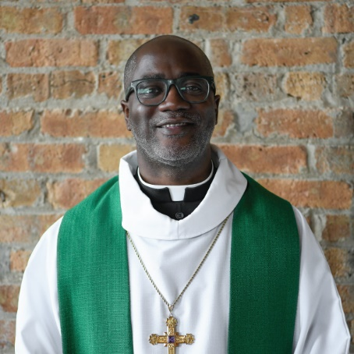
Summary
Rev. Yehiel Curry was born, raised and still resides on the south side of Chicago with his wife of 23 years, Lashonda and their three daughters: Shemiah, Ashirah, and Shekinah. His first involvement with the ordained ministry was an uncommon one. Similarly, the congregation he serves had an uncommon beginning as well. Shekinah Chapel Lutheran Church in Riverdale, Illinois, grew from a youth development and mentoring program for young African-American men called, Safe in My Brothers Arms (SIMBA), on the south side of Chicago.

Yehiel Curry attended Lewis University in Romeoville, Illinois, where he received a B.A. in Psychology and a minor in Secondary Education in 1995. After four years in the social service field, Yehiel Curry spent another four years teaching 6th grade Social Studies at Doolittle East Middle School, a Chicago Public School nestled in the Ida B. Wells public housing projects.

In 1997, he was part of a team that was helping to organize a new worshiping community in Chicago with the Evangelical Lutheran Church in America (ELCA). In 2007, Yehiel Curry began serving as the lay Mission Developer of Shekinah Chapel. Rev. Yehiel Curry was ordained on April 26, 2009, after two years of study at the Lutheran School of Theology at Chicago (LSTC) through the Theological Education for Emerging Ministries (TEEM) program. In 2012, Shekinah Chapel became an organized congregation of the ELCA and in 2013, Pastor Curry received his Master of Divinity from LSTC.

Pastor Curry was blessed to minister God’s word in Liberia & Rwanda, Africa; before 35,000 youth at the Youth Gathering; at the ELCA Churchwide Assembly and various synods throughout the U.S.

On June 8, 2019, Rev. Yehiel Curry was elected to Bishop of the Metropolitan Chicago Synod (companion synod to the Florida-Bahamas Synod). Rev. Yehiel Curry serves as a board member for Rescue, Release and Restore, Inc. NFP (RRR) – a mentoring organization with programs in six cities. RRR focuses on conflict resolution, rites of passage and cultural expression and houses the SIMBA/ Safe in My Sisters’ Arms (SIMSA) camps for African-American youth and the MYLA Camp – a multicultural leadership camp in partnership with Living Water Ministries in Michigan.

Rev. Curry is a past contributor to an ELCA worship resource, Sundays and Seasons and has authored Bring them in, train them up and ship them out and Rods and Blessing for other ELCA publications.

Rev. Curry is the recipient of:
- The Ark of St. Sabina – Dream Maker Award
- Southsiders Organized for Unity and Liberation (SOUL) – Leader of the Year

- Metro Chicago Synod AA strategy team – Spirit of Timothy Award
- Rev. John Steinbruck – Leadership Award
- Lutheran School of Theology at Chicago – Distinguish Alumni Award
- ELCA Youth Ministry Network – The Tom Hunstad Award

Pastor Curry’s life’s journey informs and influences his apprenticeship model of mentorship which maintains that you should make a friend before you try to make a member because it’s easier to quit on a denomination and harder to quit on a friend. (*weblink below)

Song Recommendations
- TFF 213 - We Shall Overcome
- ELW 325/ TFF 66 - I Want Jesus to Walk with Me
- TFF 166 - Oh, I Woke Up This Morning
- ELW 787 - On Eagle's Wings
- ELW 808 - Lord Jesus, You Shall Be My Song

Petition for prayers of the people

Weekly Prayer (for individuals, small groups or the prayer of the day...write yourself or use this one)
Magnificent and merciful God, lover of justice and equity, you call us to support the weak, to help those who suffer, and to honor all people. Equip our bishops Elizabeth, Pedro, and Yehiel to lead us in your truth. By the power of your Holy Spirit, make us advocates for your justice and instruments of your peace, so that all may be reconciled in your beloved community; through Jesus Christ our Savior. Amen

Offering Prayer
Liberating God, you break the bonds of injustice and let the oppressed go free. Receive these offerings in thanksgiving for all your works of merciful power, and shape us as people of your justice and freedom. You we magnify and adore, through Jesus our Savior, Amen.

Blessing
The God who faithfully brings forth justice and breaks the oppressor’s rod ☩ bless, strengthen, and uphold you, today and always. Amen.

Weblinks
- *https://coloringmhc.com/speaker/yehiel-curry/
- https://mcselca.org/who-we-are/bishop-yehiel-curry/
- https://lstc.edu/story/lstc-experiences-prepared-yehiel-curry-to-serve-in-multiple-capacities-within-the-church/

Video: Solutions for Today’s Church https://www.youtube.com/watch?v=8kxF5kQhkBA

