For Internal Use Only
Acknowledgement sent:

Inquiry #
LOI accepted | YES / NO
Response sent:

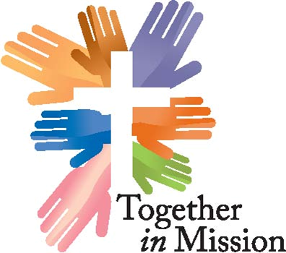

GRANT APPLICATION

Please type all answers. E-mail completed form to: tim-grant@fbsynod.org , or FAX 813-870-0826.

Legal Name of Congregation:
Address of Congregation:
City: | State: | Zip Code:
Telephone: | Fax: | Web Site:
Senior Pastor:
Telephone: | Fax: | E-mail:
Contact Person: |  | Title:
(if different from name above)
Telephone: | Fax: | E-mail:

Grant Applications are due to the Synod Office by: February 28 for Cycle I or August 31 for Cycle II.

Grant Criteria
Together in Mission looks for creative initiatives that offer innovative approaches to local, church-based ministries. We desire to support dynamic projects that show the love of Jesus in word and action.
Please provide full and complete answers to all of the following questions as this submission is your complete application for grant consideration. You will be notified if the Grant Committee requires more information to fully evaluate your application. It is important that your congregational trend report on the Synod website is current as the committee often refers to information contained therein as part of their consideration of this grant application. We would expect the completed application to be 6 to 8 pages in addition to the attachments.

- What is the name of the ministry or project you are seeking a TiM grant for and please describe it.
.

1.1 What is the purpose of this ministry and how does it complement the mission of your congregation?

1.2 Briefly share the demonstrated need and demand for this project.

1.3 Is this a new or ongoing activity? If ongoing, why are you applying for a TIM grant now?

1.4 What assumptions are you making in your plan for this ministry?

1.5 What is your target audience and how many people do you hope to serve?

1.6 What are the specific long and short-term goals of this ministry?

1.7 Describe the long-term impact of the proposed ministry.

1.8 What specific strategies are planned in order to obtain the expected outcome of this ministry?

1.9 Has the proposed project been thoroughly developed and carefully planned?

2 What is the timetable for implementation and for the achievement of both the long and short-term goals?

2.1 What is the expected life span of the project?

3 How does this project promote the purposes of Together in Mission?

3.1 Demonstrate evidence of some formal or informal connection with the ELCA, its synods, congregations, affiliated organizations, or ministries.

3.2 Please explain why Together in Mission is the most appropriate source of funding.

3.3 Will the project go forward without TIM funding?

4 What other sources of support have been requested?

4.1 Does the project include participation of community groups: ecumenical, inter-agency, or secular? If so, please provide names and associations.

4.2 How much money are you requesting and what is the total budget for this ministry? Please provide a detailed budget for this ministry including specific amounts for individual categories of revenue and expenses (feel free to attach a spreadsheet if necessary).

4.3 Is this a single year or a multi-year request? (Note: grants may be funded for up to three years. However, each year an application must be submitted and the grant will be reconsidered by the committee as part of the regular grant cycle.)

4.4 If this is a multi-year project, show previous request and grant amounts by date.

4.5 How will the project be sustained after the initial start-up grants lapse or are phased out?

5 What financial management systems and safeguards are in place?

5.1 What plans and standards for evaluation of the proposed project exist?

Supporting Documents (please attach):
- Approval in writing for the proposal submission from the Senior Pastor or other authorized representative of the requesting congregation.
- Congregational letter of support – a letter from each congregation involved in the project, stating their financial and ministry commitment to the project. The letter should briefly address how the project meets the congregation’s ministry goals and priorities, and should state the congregation’s intent to be involved through long-term connection to Word and Sacrament ministry.
- Letters of support from other key partners may be included to strengthen the application. The letters should define the partner’s relationship to the project and, where applicable, state the amount of their financial commitment to the project during the proposed grant funding cycle.
- If the applicant is a congregation, a letter of support from your conference.
- A list of the members of the Board / Mission Team, including business affiliation.

The committee will consider this application in early March for Cycle I and early September for Cycle II, and will contact you shortly after that with any further questions that the Grant Committee may have. Further information requested must be returned no later than March 31 for Cycle I or September 30 for Cycle II. The Grant Committee’s final decisions on grants will be made by April 30 for Cycle I and October 31 for Cycle II.

Send this Grant Application with attachments to: tim-grant@fbsynod.org, or via FAX 813-870-0826.

Signature of representative completing this application Date

