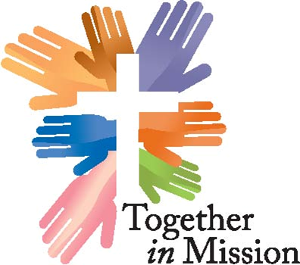

“Funding a new vision for a growing and evangelizing church.”

The purpose of the Together in Mission Fund of the Florida-Bahamas Synod is to encourage and assist in the funding of existing, as well as, new and creative ministries that best represent collaborative initiatives that strengthen leaders, transform congregations, and deepen our hearts for evangelism and outreach. Only congregations that are members of the Florida-Bahamas Synod are eligible for Together in Mission Grants.

Grant Application Process
The grant application process is a competitive one and acceptance at any stage does not guarantee funding. The steps for applying are as follows:
STEP 1: THE GRANT APPLICATION
Please provide full and complete answers to all of the following questions as this submission is your complete application for grant consideration. You will be notified if the Grant Committee requires more information to fully evaluate your application. It is important that your congregational trend report on the Synod website is current as the committee often refers to information contained therein as part of their consideration of this grant application. We would expect the completed application to be 6 to 8 pages in addition to the attachments.
STEP 2: APPLICATION REVIEW
Following submission, applications will be reviewed as follows:
- Grant Review Team Member contact: The Team Member assigned to the application will contact the applicant/congregation to confirm that application has been received, and discuss any special needs or circumstances that may exist.
- Changes: During the time that an application is under review, an applicant must notify the Team Member of any significant changes in leadership (staff or Mission Team), financial circumstances, or the capacity of the congregation to carry out the proposed activities.
Application Evaluation:
The following guidelines are used in evaluating the Grant Application:
- Alignment with the Together in Mission precepts:
    - a new vision of collaboration and support that builds on strengths and invests in emerging potential;
    - a new way of being the church together that helps us all mature in Christ and discipleship, and
    - a new model of working for justice and human care that deepens our relationships with one another.
- Evidence of broad-based financial support, with an accounting of funds received from public and private sources
- Evidence that the program or project responds to a valid need and has higher likelihood of successful implementation than other competing programs or projects
- Evidence of previous program or project success or likely success in the future
- Evidence of program or project accountability
Applicants will receive an e-mail from the Grant Review Team when the application is received electronically. After verification of all necessary information, applicant will receive an e-mail advising whether their proposal will be considered per the proposal deadlines outlined below.
Grant Timeline:
Timeline and deadlines are listed below and posted on the website at: https://fbsynod.com/mission-ministry/together-in-mission-2/

Grant Process Timeline and Due Dates
Cycle I
By February 28 | Grant Application due
By March 15 | Congregation may be contacted by the Grant Committee for further information of clarification of the Grant Application
By March 31 | Response from congregation for additional information due
By May 1 | Congregations notified of outcome of Grant review
Cycle II
By August 31 | Grant Application due
By September 15 | Congregation may be contacted by the Grant Committee for further information of clarification of the Grant Application
By September 30 | Response from congregation for additional information due
By November 1 | Congregations notified of outcome of Grant review

