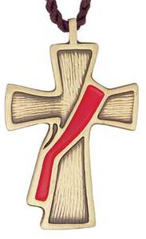
PARISH SYNOD DEACON RETREAT
Sept. 6-7, 2019
Redeemer Lutheran, Winter Park

Registration Form
If you are attending the retreat, please complete this form and return it along with your check. Do not complete this form if you ARE NOT attending the retreat. Thank You
Please Print
______ Yes, I WILL attend the retreat
______ Yes, my spouse ____________________________________________________________________will also attend.
______ Other person attending: ___________________________________________________________________________
Your Name: ____________________________________________________________Phone No. ________________________
Mailing Address: __________________________________________________________________________________________
City, State, Zip:___________________________________________________________________________________________
E-mail Address: __________________________________________________________________________________________
Home Church: ________________________________________________________Phone No. ________________________
Church Address: _________________________________________________________________________________________
City, State Zip: __________________________________________________________________________________________
Pastor’s Name: __________________________________________________________________________________________
Pastor’s E-mail Address: _________________________________________________________________________________
Any food allergies or diet requirements: Yes or No (please circle) If yes, please indicate: _____________
___________________________________________________________________________________________________________
TOTAL DUE: $ ______________ (Number of persons attending times $65.00 each)
Make Checks Payable to: Deacon Oversight Committee
***on the memo line please state “2019 Deacon Retreat”
Address the envelope to: Deacon Marcy Kysilka, 2837 Lake Baldwin Lane, Apt. B-104, Orlando, FL 32814
Deadline for registration is August 15,2019. If you have any questions, please contact the Deacon Committee Oversight chairperson by e-mail at deaconchair@yahoo.com.

