AGENDA
Synod Parish Deacon Retreat
September 6-7, 2019

Friday, September 6, 2019
4:00 PM Registration and Gathering (Have some light snacks and drinks available)
4:30 PM Welcome, Opening Prayer, Committee Introduction
4:45 PM Keynote
Deacon Connie Schmucker, Assistant to the Bishop for Leadership
6:00 PM Evening Meal
7:00 PM Keynote
Deacon Connie Schmucker, Assistant to the Bishop for Leadership
8:00 PM Contemplative Meditation
8:15 PM Worship w/Eucharist, Installation of Bishop’s Oversite Committee
9:15 PM Fellowship Time
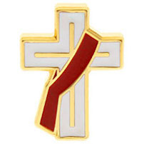
Saturday September 7, 2019
7:30 AM Order of Corporate Confession and Forgiveness
7:45 AM Registration and Gathering
8:00 AM Community Breakfast
9:00 AM Bishop’s time with Synod Parish Deacons
10:15 AM Break
10:30 AM A Gifted Group of Disciples!
Synod Parish Deacon, Jennifer Grumbling
11:30 AM Responsive Prayer
12:00 AM Lunch
12:45 PM Table Talk

JOIN US AT: Redeemer Lutheran Church, 3377 Aloma Ave, Winter Park, FL 32792

