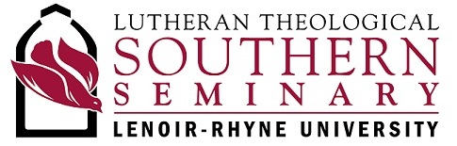

March 2019 Report to the Florida-Bahamas Synod, ELCA

Greetings in the name of our Lord Jesus Christ!

The biggest recent news on campus is the creation of the position I now hold. In order to raise the profile and improve support for LTSS, Lenoir-Rhyne University President Fred Whitt invested in a new position of leadership and structure as well as additional resources for LTSS. In the new structure, LTSS has its own full-time chief administrator (the rector and dean) who lives and works in Columbia and who reports directly to the university president. I am honored to be that administrator, and I am eager to join with leaders across all three campuses of LR to strengthen and expand the seminary’s work.

Approximately 60% of our students are members of the ELCA, with the rest coming from a variety of denominations. We speak of ourselves as “faithfully Lutheran, and warmly ecumenical.” In a broadly diverse Christian community in each class, our students are regularly called on to articulate the distinctiveness of their own traditions, just as pastors and other church leaders are called to do in the communities where they serve.

This year has also brought increased racial diversity to our campus. Beginning in January, faculty member Dr. James Thomas and interim enrollment counselor Mr. Jeffrey Howard are offering faculty and staff support to a new student group for those of African descent. Our students have been visiting African descent churches in Columbia and otherwise connecting with our neighborhood in new ways.

Thank you for your support of LTSS. One of the most important things you can do to keep the church vibrant in the next generation is to notice who in your congregation may have a calling to Christian public leadership and encouraging them to explore that call.
- Thank you for the next generation of Christian public leaders whose gifts you are nurturing even now and whom you have sent to study among us.
- Thank you for your prayers for our work as a seminary, and for our students and the ministries they will lead.
- Thank you for your gifts that support our work financially. During our last fiscal year, the Florida-Bahamas Synod supported LTSS with a gift of $67,273. We are grateful for the generous individual and congregational gifts that continue to support the work of the preparing leaders for the church.

For all the ways we are partners together, I give thanks. May God bless our shared ministry for the sake of the gospel.

Grace and peace,

Mary Hinkle Shore
Rector and Dean
Lutheran Theological Southern Seminary
of Lenoir-Rhyne University

