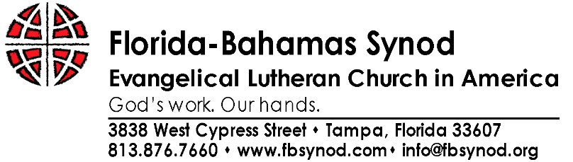
2018 Disaster Response

The Office of the Bishop has responsibility to shepherd and resource rostered leaders and congregations in times of disaster. The Bishop administers the response through Michele Hilton, Assistant to the Bishop for Administration.

The Florida-Bahamas Synod and the Office of the Bishop will work with government and ecumenical disaster response groups.

Disaster Response Procedures

- In the event of severe weather, the Office of the Bishop coordinates emergency response through Conference Deans. The Office of the Bishop will communicate via email and social media.

- In the Event a Tropical Storm Watch or a Hurricane Watch is announced by the National Weather Service, the Office of the Bishop will communicate to all Deans that a tropical storm or hurricane is possible within the next 48 hours. Deans in Conferences impacted by the warnings will be expected to contact all congregations in their Conference and advise them to prepare their properties as appropriate.

- In the event a Tropical Storm Warning or a Hurricane Warning is announced by the National Weather Service, the Office of the Bishop will communicate to all Deans that a tropical storm or hurricane is expected within the next 36 hours. Deans in Conferences impacted by the warnings will be expected to contact all congregations in their Conference and advise them to complete storm preparations and immediately leave the threatened area if so directed by area officials.

- Within 8 hours after a tropical Storm or Hurricane has impacted an area, the Office of the Bishop will schedule a conference call for all Deans to assess impact, damage and for those unaffected, to assess ability to respond.

- The Bishop, staff, deans, or designated synodical representatives will visit the affected areas as soon as practical.

- Ms. Hilton will be in conversation with the bishop, deployed staff, and deans about needs and the most helpful ways to shepherd and resource rostered leaders and congregations.

- The deans and contact persons in affected areas should continue to provide regular updates to Ms. Hilton at MicheleH@fbsynod.org or at 941.373.5596.

- Ms. Hilton will coordinate with Lutheran Disaster Response, the Florida VOAD and Volunteer Florida to identify the most appropriate responses and responsibilities.

- Volunteers will be coordinated by the Office of the Bishop.

- Financial contributions may be made:

- To the Florida-Bahamas Synod Disaster Response fund, specifically designating “Disaster Response’
- To LDR by mail to the address below,
Lutheran Domestic Disaster Response

P.O. Box #71764

Chicago, IL 60694-7164 or
- through secure credit card transaction contributions at ELCA’s web site at www.elca.org/disaster .

