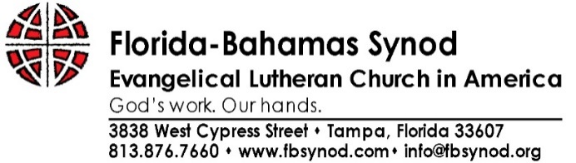

BACKGROUND VERIFICATION DISCLOSURE
The Florida-Bahamas Synod will obtain an investigative consumer report for all Synod Council officers. The investigative consumer report may include information regarding your credit worthiness, credit standing, credit capacity, character, general reputation, personal characteristics or mode of living. The following Consumer Reporting Agency will prepare the report:
ChoicePoint Services Inc. (Lexis-Nexis)
1000 Alderman Drive, Alpharetta, GA 30005

This report may be compiled with information from credit bureaus, court records repositories, departments of motor vehicles, past or present employers and educational institutions, governmental occupational licensing or registration entities, business or personal references, and any other source required to verify information that I have voluntarily supplied. I understand that I may request a complete and accurate disclosure of the nature and scope of the background verification, to the extent such investigation includes information bearing on my character, general reputation, personal characteristics or mode of living.

AUTHORIZATION & RELEASE
At any time during my tenure as an officer of the Florida-Bahamas Synod Council, I authorize any reference, supervisors, ELCA entity (including congregation, synod, churchwide organization), or any other person or organization to give the Florida-Bahamas Synod any information (including opinions) regarding my character and fitness for ministry. I also release any individual, employer, reference, synod, congregation, ELCA entity or related organization, institution, organization, or official, or any other person or organization providing information, from any liability for damages of whatever kind or nature that may exist at any time on account of compliance or any attempts to comply with this authorization, excepting only the communication of knowingly false information.

I authorize any prospective employer to conduct reference and background checks and screening, and I agree to supply additional information or consents as requested.

A signed facsimile, electronic version, or photocopy of the Authorization and Release shall be as valid as the original.

First Name: | Middle Name: | Last Name: | Suffix:
Other Names Used:
Current address: |  |  | From – To:
Previous address: |  |  | From – To:
Social Security Number: | Date of Birth: | Driver’s License #: | State Issued:
Education (Degree Obtained and Name of School): |  |  | Date Completed:
Signature: |  |  | Date:
* Date of birth is being requested for identification purposes only in obtaining accurate retrieval of records and will not be used for discriminatory purposes.

Disclosure Information

Out of care for this church, the following questions are asked of all ministers of word and sacrament making themselves available for the call to serve as Bishop of this synod.
 | Circle one:
Have you ever engaged in, been accused of, charged with, or convicted of illegal conduct or a crime, including conduct resulting in suspension or revocation of your driver’s license? If yes, please explain on attached paper. | Yes No
Do you have any health conditions (physical or psychological) or any addictive behavior, including a history of drug, alcohol, or pornographic addictions that might interfere with your ability to serve or continue serving as a leader? If yes, please explain on attached paper. | Yes No
Have you ever engaged in, been accused of, investigated for, sued, or charged with sexual misconduct, sexual harassment, substance abuse, child or spousal neglect or abuse, or financial improprieties? If yes, please explain on attached paper. | Yes No
While on the roster, have you ever engaged in, been accused of, investigated for, charged with, or disciplined for any conduct proscribed in Definitions and Guidelines for Discipline? If yes, please explain on the attached paper. | Yes No
Are you living in accord with Vision and Expectations and Definitions and Guidelines for Discipline for rostered persons in the ELCA, and do you intend to continue to live in compliance? If no, please explain on the attached paper. | Yes No
Have you ever engaged in any behavior or been involved in any situations that, if they became known, might seriously damage your ability to begin or continue in leadership and ministry? If yes, please explain on the attached paper. | Yes No
I have read the above statements and my replies are true and accurate.
______________________________________________
Print Name
Date: ____________________ Signature: _________________________________________________________
I have attached ________ additional page(s). Yes or No

Additional Information for Disclosure Form
Please provide as complete an answer as you deem appropriate on this sheet. Please make sure to number your answers to correspond to the questions. If there is more than one sheet, please number each page and note at the bottom “continued” prior to the last page.
Please write “Continued” if more pages.

