Global Mission Updates
Most of what we are hearing now in the news about Cuba and the United States is troubling and discouraging. The previous US administration had brought hope that relations between the 2 countries would “normalize” as a result of resuming dialogue and trade and easing travel restrictions. That hope was short-lived and now the current administration is attempting to roll-back the advancements that had been achieved with the support of both Americans and Cubans alike.
Recently, Rev. Joel Ortega Dopico, President of the Council of Churches of Cuba, released a statement that expresses their disappointment on President Trump’s actions and their hope for a change in this administration’s policies towards them. “This policy indicates a lack of information and knowledge about the Cuban reality: our history, sovereignty, and rights, as well as those of the people of the United States. It is divorced from the context of the time we live in today. This policy issues from a one-sided monologue that leads nowhere in the 21st century, when humanity calls for dialogue and the search for civilized solutions. We live in the era of dialogue, of mutual respect and two-way communication, in search for and construction of peace without which humanity will not be able to survive. We are confident that this backward policy is not the will of the American people or of their churches and religions, which have always advocated peace, dialogue, and normalization of relationships. We also know that it is their will that the embargo be removed, as well as that of nations expressed year after year in multiple votes at the United Nations. We express our gratitude to God and to all his sons and daughters as we continue to seek the lifting of the embargo and the search for solutions through dialogue and peace. Once again, we call for unity in prayer, action in the hope of the abundant life to which Christ calls us.”

The Cuba Team, in particular, Rev. Russell Meyer, and the ELCA Global Mission Director, Rev. Rafael Malpica, continue to be in contact with Bishop Benito and the Council of Churches of Cuba and monitor activities that impact the relationship between the two church bodies and their leadership. Please keep the Lutheran Church of Cuba in your prayers.

Contacts for Global Mission
Area | Name | Email
Presentations/General information | PJ May, Chair, GM Committee | pjnrusty@yahoo.com
Cuba - Coordinator | Rev. Dr. Russell Meyer | rmeyer@floridachurches.org
Guyana/Suriname | Rev. Kit Robison | pastorobison@gmail.com
Haiti | Rev. Stephen Winemiller | pastorsteve@faithsarasota.com
Bishop’s staff liaison | Rev. Jaime Dubon | jaimed@fbsynod.org

HAITI 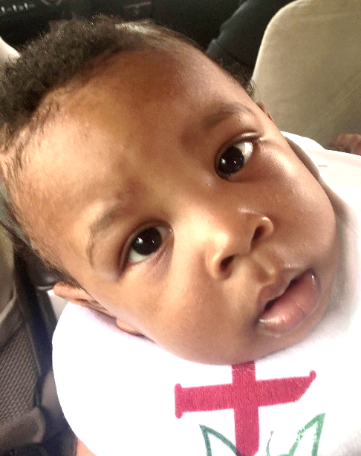
Johnson Lisandro Lauvanus, son of ELH President Rev. Livenson Lauvanus and his wife Rose, was baptized by Pastor Steve Winemiller of Faith Lutheran Church, Sarasota in Haiti on Sunday, June 18th. Godmother Jane Friburg of Venice, Florida, was also in attendance.
Infant baptism as a part of the Lutheran Church is not yet widely accepted or practiced in Haitian culture for a number of reasons. The sacrament itself is still strongly associated with the Roman Catholic church – the church of France and the former slave owners in Haiti. The Pentecostal churches are more common among Haitians and baptism is done at a later age.
Pastor Livenson was grateful to have his long-time friends and supporters from the Florida-Bahamas Synod present with him and his family as they celebrated this special time in Johnson’s life – baptized as a Child of God with the congregation of Emmanuel Lutheran Church in Gressier, Haiti, as witnesses.
The Eglise Lutherienne d’Haiti (ELH) held a General Assembly for clergy and lay delegates June 18-20, 2017 at the compound in Gressier. Unfortunately, the ELH had to deal with disciplinary matters with regards to one of their clergy. Their constitution document stood the test however, and they were able to deal with the matter accordingly. Elections were also conducted and Rev. Joseph Livenson Lauvanus was re-elected as President for a 5 year term.

We give and thanks and praise to God that the news out of Haiti is encouraging!
Jim Noss, our “man on the scene” in Haiti – has made 2 trips in the last month and reports exciting and positive developments. The compound in Gressier will now be home to about 30 children and staff of an orphanage that has long been supported by Advent Lutheran Church in Wisconsin. The school building is currently being used as living quarters, cooking facility, and school however plans are in place for the dormitory building to be finished and eventually used to house the children. Jim put in many hours and miles between Wisconsin, Chicago, and Haiti to help make this happen. The ELH and the ELCA are delighted about this partnership and excited about what the future may hold.
Jim has also been helping get the bread bakery in Jacmel up and running. Jim recently helped by teaching bookkeeping skills and repairing the solar panel system – truly a “jack of all trades”!

Pr. Livenson reports that while the Seed Project suffered significant loss in the first planting due to heavy rain and flooding (again!) in Les Cayes, there are signs of hope and success in Jean Rabel and from the second planting in Les Cayes. Pr. Livenson plans to try and travel to Les Cayes in the coming weeks and send back photos to share with us.
GUYANA/SURINAME
Report on Guyana/Suriname Trip, Submitted by Steve Rizzo
On April 24, six members of the Florida-Bahamas Synod Suriname-Guyana Subcommittee departed airports in Miami and Orlando to attend the 74th annual convention of the Evangelical Lutheran Church in Guyana (ELCG). However, the team’s first stop would be the country of Suriname, where our delegation was invited to first visit the Evangelisch Lutherse Kerk Suriname (ELKS, or Evangelical Lutheran Church in Suriname).
The team included subcommittee chair Rev. Tom Unrath, Rev. Kit Robison, Marcee Strickland, Chris Klafs, and Steve and Leandra Rizzo. Rev. Robison was being introduced to his new role as chair. It was the first trip to the two countries for Rev. Robison, who leads a congregation in Miami Springs and formerly served a Lutheran church in Quito, Ecuador.

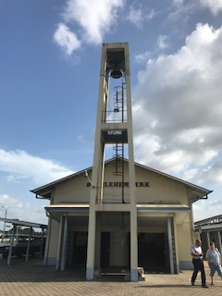
  - 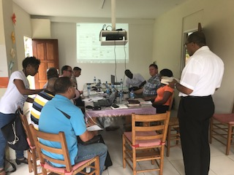
During our trip to both companion churches we shared much prayer, joy, and conversation as brothers and sisters in Christ. We also shared our common concerns of declining numbers of youth and young families, drops in Sunday School and confirmation enrollment and attendance, problems with church polity and governance, and lack of opportunities for faith formation and leadership development. To these concerns, we were able to share encouragement, support and affirmation of our accompaniment as a global and interconnected church.
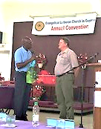
It was a bittersweet trip for Rev. Unrath, who has for the past ten years served as chair of the Suriname-Guyana subcommittee. Rev. Unrath would be making his last trip to Suriname and Guyana due to health reasons. Rev. Unrath is shown here receiving a small gift from ELCG President Leroy Nicholson as a token of appreciation for his dedication and service.
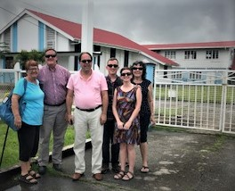
Everywhere we went, we were treated to incredible hospitality. We certainly never went hungry, thanks to the frequent meals of various cultural stripes. For those returning to Suriname and Guayana, old friendships were affirmed, while for those visiting for the first time, many new friendships were kindled.
We are all excited to continue working with our companion churches in Guyana and Suriname, and with each other.
From L-R – Chris Klafs, Rev. Tom Unrath, Rev. Kit Robison, Steve and Leandra Rizzo, and Marcee Strickland in front of Redeemer Lutheran Church, New Amsterdam, Guyana.

Young Adults in Global Mission (YAGMs) – Homecoming and re-entry
Three young adults from the FB Synod will be arriving home and beginning the task of “re-entry” into a culture they have been absent from for a year. It’s not as easy as one might think! Ben and Kyle have had to learn completely new languages, and even Becca, while serving in an English-speaking country – has probably had to adjust to new customs and idioms. All have been totally immersed in different communities, families, cultures and traditions. They will need time - to reflect on what this past years’ experience means for them and the choices they make for the future. They will need an outlet – to share their excitement and enthusiasm for what they learned while abroad. There’s nothing worse than to come home full of ideas and new learnings and have no one interested in hearing about it! They will need prayers – that their homecomings are joyful and the transition back to American culture eased by those willing to hear their stories and share their experiences.
Please pray for our YAGMs and consider inviting them to come and speak to your congregation, conference, or youth groups!

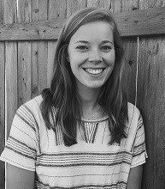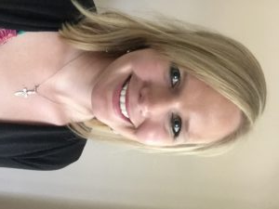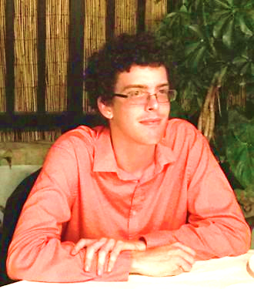
Becca Williams – England Kyle Marie Jacobson – Cambodia Ben Smith – Madagascar

