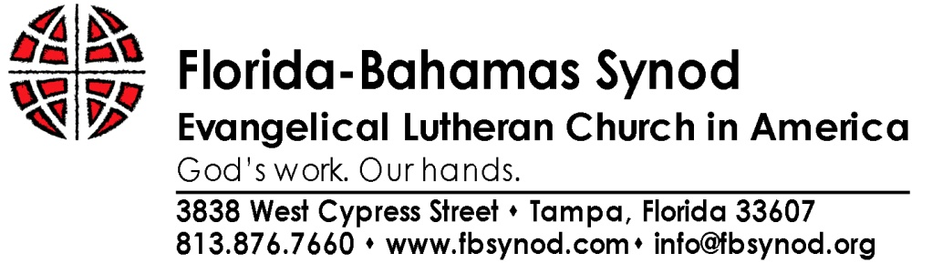

Travel Equalization Plan

The composite travel distance for one vehicle per Florida congregation* to our defined central Florida Assembly locations equals approximately 60,000 miles. Obviously, congregations near them travel a short distance and have minimal costs whereas congregations at the extreme ends of the synod have much higher costs for travel. The greater travel distances for some congregations represent an ongoing unfair financial burden for authorized representation when the Assembly is held at repeating central locations. For that reason, the 1991 Assembly (Resolution 91-7) directed that a plan for sharing of travel costs by all congregations be instituted to equalize those costs for congregations. The plan follows:

- Each synod congregation is assessed a proportionate share of the total travel cost based upon a per-mile rate. In return, each Florida congregation* applies for a travel reimbursement amount at the same rate for miles actually traveled. As a result, congregations at a distance farther than the average distance would receive more in return than the original assessment. Congregations at a distance less than the average would receive reimbursement funds less than the assessment amount.
- The assessment for each congregation for our coming Assembly is $40. Each congregation will have the opportunity to request a travel refund of $.14 per mile. The rate will apply whether the congregation delegation chooses to drive or to take other transportation. Larger congregations entitled to more than four voting members at the Assembly may require more than one vehicle and would apply for the second vehicle at the same rate with four persons per automobile as the standard.
To illustrate:

Example 1. Travel distance 350 miles round trip

Qualified Reimbursement $49
Initial Assessment $40
Net cash to congregation $9

Example 2. Travel distance 100 miles round trip

Qualified Reimbursement $14
Initial Assessment $40
Net cash to congregation ($34) **
** Distance traveled doesn’t meet minimum required for reimbursement.

* The Synod Council will establish a separate equitable reimbursement package for airfare for Assembly members from the Bahamas.

NOTE: ALL CONGREGATIONS MUST PAY THE TRAVEL EQUALIZATION FEE OF $40. If this fee is not paid with your registration, your congregation will be invoiced for the fee after the assembly. Please help us keep costs down by paying the fee online when you register.

Travel Equalization Voucher
(One voucher per Congregation)

This form can be submitted as you leave the assembly gathering

or immediately following the assembly to insure prompt reimbursement. *

*Please submit this form no later than November 30th

Your congregation must have paid the $40 Travel Equalization Fee

when you register for the assembly

Congregation:
Address:
City/Zip:
Date:
Number of voting members:

Mileage**: X $0.14/mile =

The 1991 Florida-Bahamas Synod Assembly, Resolution 91-7, directed the Travel Equalization Plan. It mandates the sharing of travel costs by all congregations to equalize costs for all attendees.

Each congregation is assessed a proportionate share for the total cost. In return, each Florida congregation that has paid its assessment applies for a travel reimbursement amount at the same rate for miles actually traveled. As a result, congregations at a distance farther than the average distance would receive more in return than the original assessment. Congregations at a distance less than the average would receive reimbursement funds less than the assessment amount.

Each congregation is being assessed $40.00. Each congregation will have the opportunity to request a travel refund of $0.14 per mile. The rate will apply whether the congregation delegation chooses to drive or to take other transportation. Reimbursement will be at $0.14 per mile if sufficient funds are in the equalization pool. The mileage reimbursement rate will be adjusted downward if necessary.

Vouchers are honored through July 31st. (Larger congregations entitled to more than four voting members at the Assembly may require more than one vehicle and would apply for the second vehicle at the same rate with four persons per automobile as the standard.)

** Please print and attach a Mapquest (or similar trip calculator computation) trip plan showing your mileage. In the absence of an attached trip calculation, one will be obtained for the distance from your congregation to the Assembly and back and that will be the mileage used for computation.

