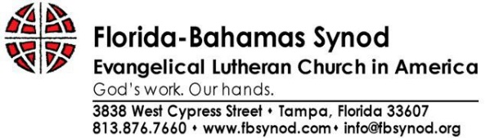

May 25, 2017

Congratulations! One of your students has been selected to participate in the 2017 Florida-Bahamas Synod Assembly and Bishop Election, October 12-14, 2017. The Florida-Bahamas Synod of the Evangelical Church in America is made up of nearly 180 congregations in Florida and the Bahamas and holds it assembly annually. The Synod Assembly is the highest legislative authority of the Synod and convenes to:

- Conduct the election of a Bishop, and other leaders,
- adopt the synod’s ministry spending plans and articulate program priorities for the next year,
- receive and act upon reports from ministry areas and agencies of the synod, and
- conduct other business as the synod council or assembly may deem necessary.

Youth voting members to the assembly have a vital opportunity to add their voice to all aspects of the assembly, including important discussions about the church’s priorities, leaders, and spending plan. Seeing and participating in the governance and community life of the synod has positive impact beyond the assembly. Youth who are involved in the synod assembly may also serve in student government leadership at their school, organize community outreach and community service projects at home, volunteer or work in community development agencies and confidently speak up about the priorities and spending plans of organizations they care about.

We continue to value the voice and presence of young leaders in our Synod and we encourage each congregation to send a youth voting member to the Assembly. We especially want our youth to be a part of electing a new Bishop and have a voice in who will lead and guide our Synod over the next six years. We are intentional about spending time debriefing and reflecting with youth voting members throughout the assembly, and discussing ways they can return to their churches, schools and communities to serve as leaders. We believe the presence of youth in our assembly is important for both the work we do and for the development of the youth.

I write to request that you excuse the absence of your student for this important event. We certainly understand the value and importance of education and appreciate your role in equipping young people with the necessary tools and experience to be productive in all aspects of life. We believe finding ways for young people to be actively involved in this level of the faith community is in line with our mutual commitment to healthy young people and healthy communities. If you have any questions or need any further information, please feel free to contact me.

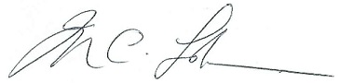
In Christ,
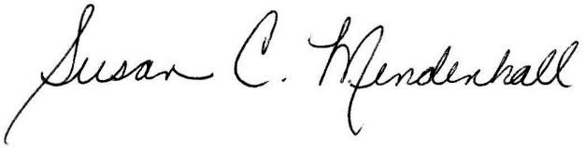

Susan C. Mendenhall, ELCA Deacon The Rev. Marcus C. Lohrmann
Director for Youth, Young Adult and Outdoor Ministries Bishop, Florida-Bahamas Synod, ELCA
Florida-Bahamas Synod/NovusWay Ministries
Suem@FBSynod.org * 727-415-9887

